 |  |  | Gospel Oak School  Bilston Road  Gospel Oak  Tipton  West Midlands  DY4 0BZ  T 0121 556 1351  F 0121 506 7833  W www.gospeloakschool.co.uk
11th March 2024 |  |  | Our Ref: SBO/EJH/819  Your Ref:
Dear Parent/Carer,
Re: | Absence Recording
Please can we remind you that it is the responsibility of a child’s parents/carers to inform school of their absence.
Contact from yourselves is required each day of your child’s absence; this needs to be done before 8.30am. To record an absence you need to use the Arbor app, instructions to do this are below. Alternatively, you can email attendance@gospeloakschool.co.uk or call 0121 556 1351 leaving a voicemail:-
Arbor Parent Absence Reporting

To report your child’s absence from school on a daily basis, you will need to log into your Arbor App as normal and follow the below step’s: -

- If you have more than one child attending Gospel Oak School, you will need to choose which child that you are reporting absence for. If both, then you ideally need to report absences separately.

- When you are on your child’s profile to the bottom right-hand corner of the screen there is a white circle that you will need to press: -

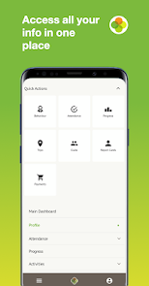
Page 1 of 2

- Once pressed, then click onto messages

- Press green box “Send New Message”

- Type message you wish to send

- Lastly press green box “Send Message”

- We will then receive your message and update our records.

If your child is required to attend a medical or dental appointment, please ensure, where possible that this is made out of school hours. Medical evidence, such as screenshot, letters or appointment cards will need to be forwarded to school for record keeping. Any medical appointments that are not supported with evidence, may be coded as O (unauthorised absence).
Please can I remind you that we no longer are using Edulink, therefore, if you put any communication via this application, we will not see it.
Thank you for your continued support.
With Kind Regards
Yours sincerely
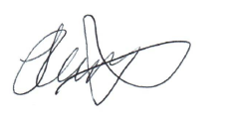

Stacy Bott
Vice Principal

Page 2 of 2

