**Summer 2024**

**Year 8 into Year 9:**

**Summer Learning Activities**

Name: ____________________

In this booklet you will find learning tasks linked to every subject you have been studying this year. These tasks have been planned to help you to further develop learning from Year 8 and to support you in getting ready for Year 9.

We expect you to:

1. Read the information about each task carefully.
2. Complete the task and answer the questions linked to the task.
3. Bring your completed booklet when we come back to school in September.

There are also a number of activities to help you with your wider learning which goes beyond the classroom. Have a look at these activities and complete any which appeal to you.

**Year 8 into Year 9 Art**

**Task**

|  |  |  |
| --- | --- | --- |
| **Key Focus Area** | **Task** | **Evidence** |
| Drawing Skills – Developing an understanding of the formal elements Form, Tone and Composition | Complete a drawing from primary or secondary observation using pencil on paper of an object from around the home. This could be an item of food or drink or a personal item such as a phone, watch or even cosmetic items.  You must show an understanding of the following elements you have learned from throughout year 8 within your work;   * **Tone** * **Form** * **Composition** * **Texture** | Drawing on A4 paper of an object using pencil shading, bring this to your first Art lesson. |

1. What did you enjoy about this task?
2. What do you now think you can do better than you did before completing this task?
3. What did you find challenging about this task?
4. What do you think you would need to do next to continue to develop your learning from this task?
5. Do you have any other comments about this task?

**Year 8 into Year 9 Dance**

**Task**

|  |  |  |
| --- | --- | --- |
| **Key Focus Area** | **Task** | **Evidence** |
| Basics of Hip-Hop and Commercial dance.  How music artists use dance to sell their image. | Choose one artist from the list below:   * Michael Jackson * Beyonce * Justin Bieber * Dua Lipa * Janet Jackson   Research the artist – find out about their dance background and choose 1 video to watch and analyse.  You may wish to consider:   * How important was dance in making the video successful? * Did the dance become iconic? * Is there any moves/music videos that they have created that have become famous/well known?   Create a poster or a leaflet to record the information you have gathered.  Include drawings, pictures, diagrams and text. | A leaflet/poster of A3/A4 size including drawings, pictures, diagrams and text.  **Be creative and make it eye catching!!** |

1. What did you enjoy about this task?
2. What do you now think you can do better than you did before completing this task?
3. What did you find challenging about this task?
4. What do you think you would need to do next to continue to develop your learning from this task?
5. Do you have any other comments about this task?

**Y8 into Year 9 Drama**

**Task**

|  |  |  |
| --- | --- | --- |
| **Key Focus Area** | **Task** | **Evidence** |
| **‘THE BIG THREE’ THEATRE PRACTITIONERS**  To develop an understanding of theatre practitioners and the key features of different styles of theatre. | Research the big three theatre practitioners and their style of theatre:   1. **Constantin Stanislavski- Naturalistic theatre** 2. **Bertolt Brecht- Epic theatre** 3. **Antonin Artaud- Theatre of Cruelty**   Choose your **favourite practitioner** and design a poster on this practitioner and their style of theatre.  **You may wish to include:**  -Background information on the practitioner  -Techniques used by this practitioner  -Strategies used by this practitioner  -Desired effect on the audience  -Examples of plays they have written/produced | A3/A4 sized poster on your favourite practitioner.  Include drawings, pictures, diagrams and text. |

1. What did you enjoy about this task?
2. What do you now think you can do better than you did before completing this task?
3. What did you find challenging about this task?
4. What do you think you would need to do next to continue to develop your learning from this task?
5. Do you have any other comments about this task?

**Year 8 into Year 9 DT**

**Task**

|  |  |  |
| --- | --- | --- |
| **Key Focus Area** | **Task** | **Evidence** |
| DESIGNING A PRODUCT WHICH IS FIT FOR A PURPOSE | Design a pair of earphones that would be suitable for a teenager of any gender. The headphones should fit on a person’s head or within their ears comfortably in order to listen to music.  **SUCCESS CRITERIA**   * Design using line drawing * Rendering to show light and dark * Annotation to explain what materials can be used   **CHALLENGE**   * Details of manufacturing methods and machinery that can be used to make your product | A drawing on A4 paper in pen or pencil of your earphones |

1. What did you enjoy about this task?
2. What do you now think you can do better than you did before completing this task?
3. What did you find challenging about this task?
4. What do you think you would need to do next to continue to develop your learning from this task?
5. Do you have any other comments about this task?

**Year 8 into Year 9 English**

**Task**

|  |  |  |
| --- | --- | --- |
| **Key Focus Area** | **Task** | **Evidence** |
| Flipped learning to provide context for Dystopian Writing | Read a dystopian book, that you either have at home, or on Sparx reader. Some suggestions are: The Hunger Games, Scythe, Ready Player One, Divergent, The Maze Runner, Red Rising.  Watch the video below, to give you advice on how to write a piece of dystopian fiction effectively.   1. Bitesize Revision> English Language > Writing Fiction  * <https://www.bbc.co.uk/bitesize/guides/zy47xsg/revision/3>   Write the opening to a description based on the image below.  Dystopian fiction: Is it really just fiction? – The Cougar Star | Students need to bring to their first lesson their start of their description. |

1. What did you enjoy about this task?
2. What do you now think you can do better than you did before completing this task?
3. What did you find challenging about this task?
4. What do you think you would need to do next to continue to develop your learning from this task?
5. Do you have any other comments about this task?

**Year 8 into Year 9 Food**

**Task**

**This summer's food challenges are**

1. **Try a food you have never tried before and record what you liked about it and what you disliked about it.**
2. **Watch a cooking program,  read a recipe book or magazine or watch a cooking You Tube video and record any new knowledge that you have learnt**
3. **Find 5 cooking utensils that you have in the kitchen and explain what their function is and what recipe you would use it for**
4. **With adult supervision ask if you can help in the kitchen and take a photograph of your work**
5. **Write a paragraph on who you would like to eat dinner with explaining what you would eat, where you would eat it and why you would like to share the meal with that person**
6. What did you enjoy about this task?
7. What do you now think you can do better than you did before completing this task?
8. What did you find challenging about this task?
9. What do you think you would need to do next to continue to develop your learning from this task?
10. Do you have any other comments about this task?

**Year 8 into Year 9 Geography**

**Task**

|  |  |  |
| --- | --- | --- |
| **Key Focus Area** | **Task** | **Evidence** |
| The UK Coastline | The UK has some beautiful stretches of coastline and some great beaches and seaside towns to visit.  Either:  Create a labelled map of the UK with at least 10 seaside towns labelled on accurately.  **OR**  Choose one seaside town and create a tourist poster or leaflet describing what it is like and what there is to do for tourists. | 🗸 Labelled map Or 🗸 Leaflet/poster |

1. What did you enjoy about this task?
2. What do you now think you can do better than you did before completing this task?
3. What did you find challenging about this task?
4. What do you think you would need to do next to continue to develop your learning from this task?
5. Do you have any other comments about this task?

**Year 8 into Year 9 History**

**Task**

|  |  |  |
| --- | --- | --- |
| **Key Focus Area** | **Task** | **Evidence** |
| **British History through time Research**  Many of the units in Year 9 look at wide periods of time, so having awareness of significant events in British history is very important. | Using the internet and other resources (these could be from your local library), create a timeline of 10 significant events in British history.  You could include:   * World War Two * Windrush * The Industrial Revolution * The Tudor Period * World War One * The Cold War   Website that will give a starting point are below:  [The 10 Most Important Events in British History: Part Two – 1500 AD to the Present Day - Oxford Royale Academy (oxford-royale.com)](https://www.oxford-royale.com/articles/important-events-british-history-after-1500/)  [The most important dates in British history | Britain Explained](https://britainexplained.com/the-key-moments-in-british-history/)  [The Most Important Events in British History: A Timeline - Historians For Britain](https://www.historiansforbritain.org/important-events-british-history-timeline/) | **Timeline (Printed or on paper and hand drawn)** |

1. What did you enjoy about this task?
2. What do you now think you can do better than you did before completing this task?
3. What did you find challenging about this task?
4. What do you think you would need to do next to continue to develop your learning from this task?
5. Do you have any other comments about this task?

**Year 8 into Year 9 IT**

**Task**

|  |  |  |
| --- | --- | --- |
| **Key Focus Area** | **Task** | **Evidence** |
| Programming | 1. Using the correct symbols:   Can you give a list of instructions (pseudo code) in order to:     1. make a cup of tea; 2. order a pizza with a choice of 3 toppings, plus a side order.      1. On paper, could you re-design the school website.   This MUST include:   * Navigation; * Images; * Logo; * Videos     Useful website:  [Flowcharts - Designing an algorithm - KS3 Computer Science Revision - BBC Bitesize](https://www.bbc.co.uk/bitesize/guides/z3bq7ty/revision/3) | Make a poster/leaflet |

1. What did you enjoy about this task?
2. What do you now think you can do better than you did before completing this task?
3. What did you find challenging about this task?
4. What do you think you would need to do next to continue to develop your learning from this task?
5. Do you have any other comments about this task?

**Year 8 into Year 9 Maths**

**Task**

|  |  |  |
| --- | --- | --- |
| **Key Focus Area** | **Task** | **Evidence** |
| Estimating calculations and understanding the value of products  Angles on Parallel lines | Go shopping with a member of your household. When shopping use your rounding skills to the nearest 50p. Round the price of each item bought to estimate the total cost of the shopping. Challenge the people shopping with you to see who gets closest to the real value. If you can, do this once per week and keep a record of who wins.  ‘Be the teacher’ Find yourself some chalk and watch the video below to revise your understanding of ‘Angles on parallel lines’. Ask someone in your household to play the role of someone who doesn’t understand the topic. Go outside and use the chalk and the floor to deliver your lesson. The lines on slabs are very useful but you must make sure the area around where you are teaching is safe for everyone first. You can use paper inside if you don’t have chalk.  <https://youtu.be/mM-PU6hmkrg>  If you enjoy this you could do some more topics as well | You could write your estimate on the receipt or keep a record of your estimate and the actual cost  Take a photo of your work and bring it in or email your new teacher in September. You could ask your student to write a summary of how good you are as a teacher |

1. What did you enjoy about this task?
2. What do you now think you can do better than you did before completing this task?
3. What did you find challenging about this task?
4. What do you think you would need to do next to continue to develop your learning from this task?
5. Do you have any other comments about this task?

**Year 8 into Year 9 MFL**

**Task**

|  |  |  |
| --- | --- | --- |
| **Key Focus Area** | **Task** | **Evidence** |
| French- speaking world |  | Tasks completed |

1. What did you enjoy about this task?
2. What do you now think you can do better than you did before completing this task?
3. What did you find challenging about this task?
4. What do you think you would need to do next to continue to develop your learning from this task?
5. Do you have any other comments about this task?

**Year 8 into Year 9 Music**

**Task**

|  |  |  |
| --- | --- | --- |
| **Key Focus Area** | **Task** | **Evidence** |
| To introduce the idea of repeated patterns in music, called ostinatos.  Exploring and listening to different genres of music. | <https://www.youtube.com/watch?v=i1L6p4B2hBs>  Using the link above, listen to the *first 25 seconds* of ‘The Clocks.’   1. The piece starts with a repeated musical pattern called an OSTINATO. How many **different** notes are in the ostinato? 2. Can you name 2 instruments playing the ostinato? 3. Does the ostinato sound smooth or spiky? 4. Is the melody (tune) smooth or spiky? 5. Which instrument is playing the melody? 6. How does the composer create the feel of a ‘clock’? | Answering of questions through listening activity. |

1. What did you enjoy about this task?
2. What do you now think you can do better than you did before completing this task?
3. What did you find challenging about this task?
4. What do you think you would need to do next to continue to develop your learning from this task?
5. Do you have any other comments about this task?

**Year 8 into Year 9 RE**

**Task**

|  |  |  |
| --- | --- | --- |
| **Key Focus Area** | **Task** | **Evidence** |
| Laws and Rules | Research the Laws and rules for religions using [Religious Studies KS3: L is for Laws and Rules - BBC Teach](https://www.bbc.co.uk/teach/class-clips-video/religious-education-ks3-a-z-of-religion-and-beliefs-l-is-for-laws-and-rules/zmkcwty)  Produce a poster include at least TEN key facts | Poster |

1. What did you enjoy about this task?
2. What do you now think you can do better than you did before completing this task?
3. What did you find challenging about this task?
4. What do you think you would need to do next to continue to develop your learning from this task?
5. Do you have any other comments about this task?

**Year 8 into Year 9 Science**

**Task : Produce an accurate scientific model**

|  |  |  |
| --- | --- | --- |
| **Key Focus Area** | **Task** | **Evidence** |
| Modelling in science | You can choose one of the three tasks below.  1 – Biology – Build a model of a specialised cell (e.g. Red blood cell, root hair cell etc). Label the parts of the cell and describe their function  2 – Chemistry – Build a working model of a volcano (a good method can be found here <https://www.youtube.com/watch?v=9b_gltKtERY>)  3 – Physics – Build a model of the solar system. Label all of the planets along with any interesting things you can find out about each one. | Bring in your model in the first week back |

1. What did you enjoy about this task?
2. What do you now think you can do better than you did before completing this task?
3. What did you find challenging about this task?
4. What do you think you would need to do next to continue to develop your learning from this task?
5. Do you have any other comments about this task?

**Learning Beyond the Classroom**

Here are some ideas for activities you can try to help develop your learning even further:

1. Watch some GCSEPods.
2. Visit a local museum.
3. Visit a local art gallery.
4. Add up the cost of your shopping when you are going around the supermarket and see if you are right when you get to the check-out.
5. Read a book and write a review about it.
6. Decide on a title for a book you would like to write and create a book cover for it.
7. Plan a journey using google maps, or a traditional map.
8. Ask people at home how to take the gas and/or electricity meter reading; what do you do when the reading has been taken?
9. Try some origami.
10. Do a jigsaw puzzle.
11. Have a look around the park or garden; can you find some leaves or twigs that you can use to create your own wildlife image. Only use things which have fallen to the ground already.

Have a go at cooking this recipe:

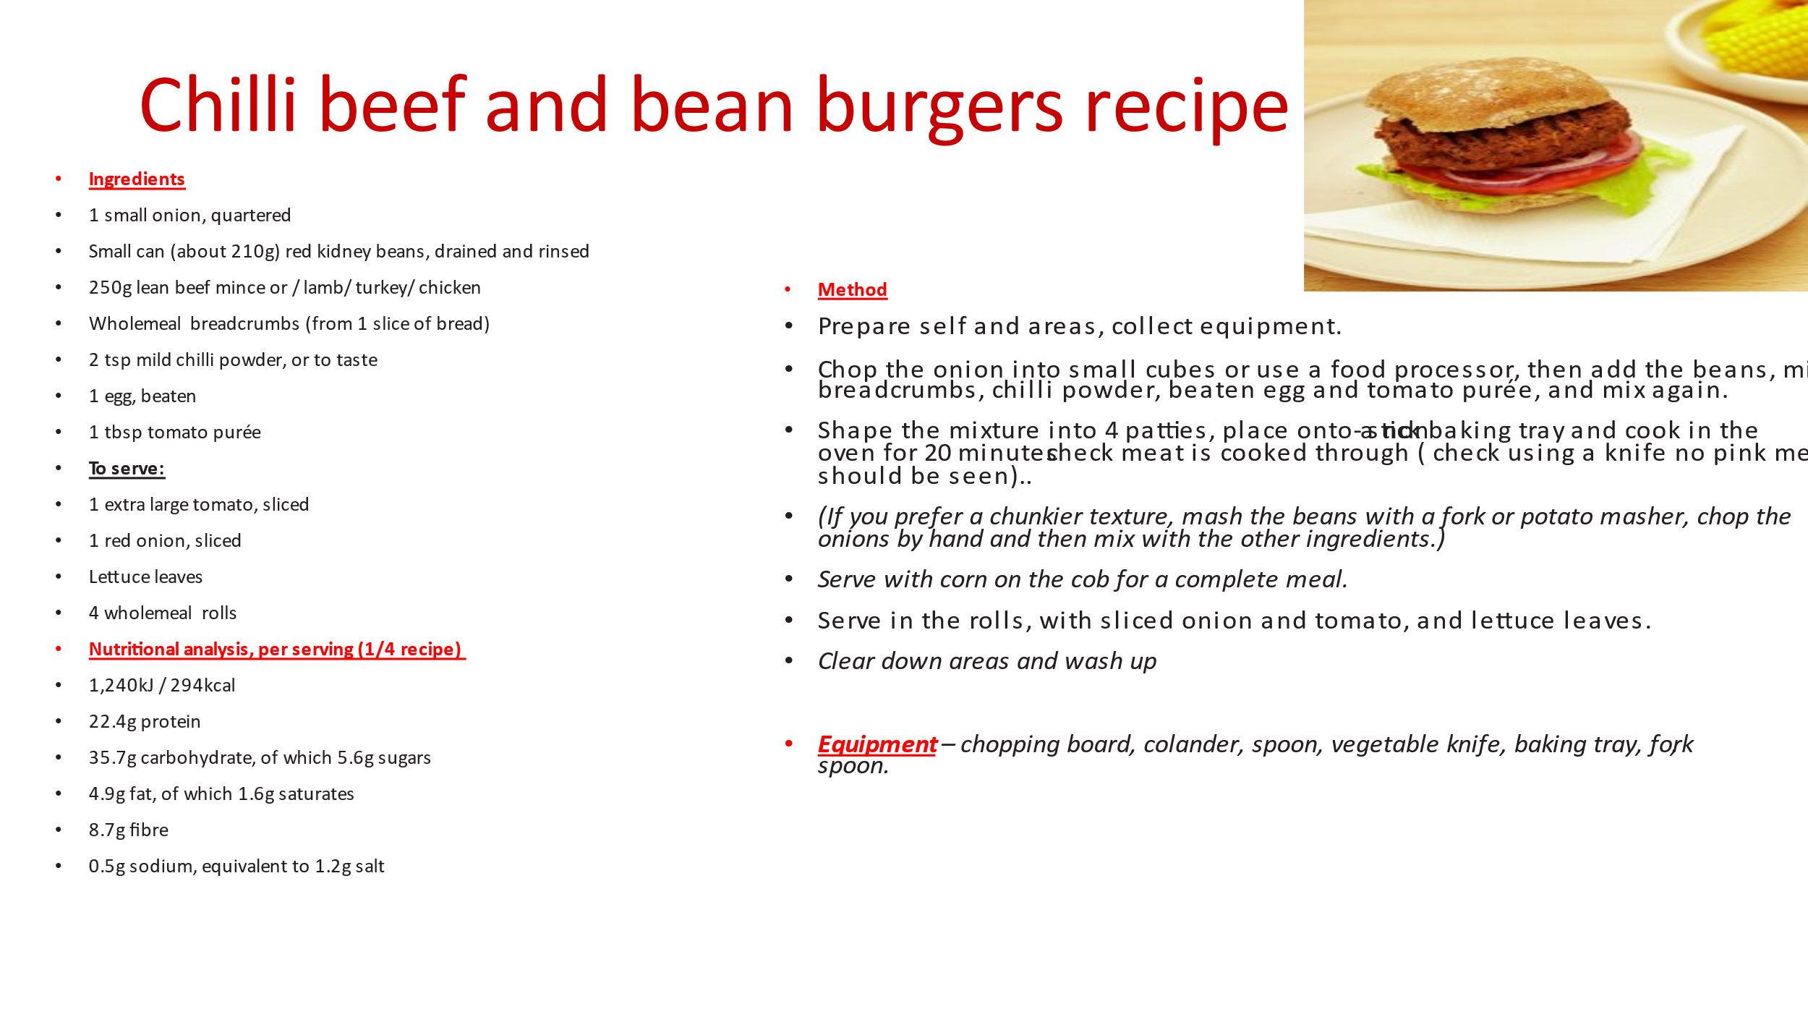

How would you change this recipe if you are a vegetarian, or cooking for someone who is vegetarian?