**Summer 2024**

**Year 7 into Year 8:**

**Summer Learning Activities**

Name: ____________________

In this booklet you will find learning tasks linked to every subject you have been studying this year. These tasks have been planned to help you to further develop learning from Year 7 and to support you in getting ready for Year 8.

We expect you to:

1. Read the information about each task carefully.
2. Complete the task and answer the questions linked to the task.
3. Bring your completed booklet when we come back to school in September.

There are also a number of activities to help you with your wider learning which goes beyond the classroom. Have a look at these activities and complete any which appeal to you.

**Year 7 into Year 8 Art**

**Task**

|  |  |  |
| --- | --- | --- |
| **Key Focus Area** | **Task** | **Evidence** |
| **IDENTITY**  Drawing Skills – Developing an understanding of the formal elements Form, Tone and Composition | Complete a drawing from primary or secondary observation using pencil on paper of an object which shows an aspect of your identity. This could be an item of clothing such as a shoe, a favourite electronic device or even cosmetics.  You must show an understanding of the following elements you have learned from throughout year 7 within your work;   * **Tone** * **Form** * **Composition** | Drawing on A4 paper of an object using pencil shading, bring this to your first Art lesson. |

1. What did you enjoy about this task?
2. What do you now think you can do better than you did before completing this task?
3. What did you find challenging about this task?
4. What do you think you would need to do next to continue to develop your learning from this task?
5. Do you have any other comments about this task?

**Year 7 into Year 8 Dance**

**Task**

|  |  |  |
| --- | --- | --- |
| **Key Focus Area** | **Task** | **Evidence** |
| Dance Style –  Finding out about Dance through the Decades! | Choose a decade (or 2) from the list below:   * 1920 – Charleston * 1950 – Rock n’ Roll * 1990 – Hip Hop   Find out as much as you can about this style of dance including:   * What did people wear? Was it important? * What was the music like? * What dance steps were used? * Who were the pioneers of the style.   Present your information in a poster/leaflet. | A poster / leaflet of A3/A4 size including drawings, pictures, diagrams and text.  **Be creative and make it eye catching!!** |

1. What did you enjoy about this task?
2. What do you now think you can do better than you did before completing this task?
3. What did you find challenging about this task?
4. What do you think you would need to do next to continue to develop your learning from this task?
5. Do you have any other comments about this task?

**Year 7 into Year 8 Drama**

**Task**

|  |  |  |
| --- | --- | --- |
| **Key Focus Area** | **Task** | **Evidence** |
| **GREEK THEATRE**  To discover the origins of theatre and broaden your understanding of the key features of Greek theatre. | Create a poster on Greek theatre.  You may wish to research:  **-Greek Gods/ mythology**  **-Tragedy Vs Comedy**  **-Amphitheatre**  **-Sophocles (writer of numerous Greek tragedy plays)**  Include drawings, pictures, diagrams and text. | A poster of A3/A4 size including drawings, pictures, diagrams and text.  **Be creative and make it eye catching!!** |

1. What did you enjoy about this task?
2. What do you now think you can do better than you did before completing this task?
3. What did you find challenging about this task?
4. What do you think you would need to do next to continue to develop your learning from this task?
5. Do you have any other comments about this task?

**Year 7 into Year 8 DT**

**Task**

|  |  |  |
| --- | --- | --- |
| **Key Focus Area** | **Task** | **Evidence** |
| DESIGNING A PRODUCT WHICH IS FIT FOR A PURPOSE | Design a pair of earphones that would be suitable for a teenager of any gender. The headphones should fit on a person’s head or within their ears comfortably in order to listen to music.  **SUCCESS CRITERIA**   * Design using line drawing * Rendering to show light and dark   **CHALLENGE**   * Details of materials that can be used | A drawing on A4 paper in pen or pencil of your earphones |

1. What did you enjoy about this task?
2. What do you now think you can do better than you did before completing this task?
3. What did you find challenging about this task?
4. What do you think you would need to do next to continue to develop your learning from this task?
5. Do you have any other comments about this task?

**Year 7 into Year 8 English**

**Task**

|  |  |  |
| --- | --- | --- |
| **Key Focus Area** | **Task** | **Evidence** |
| Reading and Summary | Choose *The Crossing*, which has been provided for you.  When you have finished reading this book, create a book review including the following:     * What genre is *The Crossing?* * What is it about? * What key themes were included in the book? * Tell me about the protagonist. * Tell me about the antagonist. * What did you enjoy about the book? * What did you not enjoy about the book? * What quote from the book do you think sums up the story and why? * Summarise the novel in 20 words or create an image that represents the book. | Written or typed book review. |

1. What did you enjoy about this task?
2. What do you now think you can do better than you did before completing this task?
3. What did you find challenging about this task?
4. What do you think you would need to do next to continue to develop your learning from this task?
5. Do you have any other comments about this task?

**Year 7 into Year 8 Food**

**This summer's food challenges are**

1. **Try a food you have never tried before and record what you liked about it and what you disliked about it.**
2. **Watch a cooking program,  read a recipe book or magazine or watch a cooking You Tube video and record any new knowledge that you have learnt**
3. **Find 5 cooking utensils that you have in the kitchen and explain what their function is and what recipe you would use it for**
4. **With adult supervision ask if you can help in the kitchen and take a photograph of your work**
5. **Write a paragraph on who you would like to eat dinner with explaining what you would eat, where you would eat it and why you would like to share the meal with that person**

**Task**

1. What did you enjoy about this task?
2. What do you now think you can do better than you did before completing this task?
3. What did you find challenging about this task?
4. What do you think you would need to do next to continue to develop your learning from this task?
5. Do you have any other comments about this task?

**Year 7 into Year 8 Geography**

**Task**

|  |  |  |
| --- | --- | --- |
| **Key Focus Area** | **Task** | **Evidence** |
| What is India like? | Research the location and the physical geography of India.  Create a mind map or poster about what you have found out. | 🗸 Mind map or poster about the geography of India |

1. What did you enjoy about this task?
2. What do you now think you can do better than you did before completing this task?
3. What did you find challenging about this task?
4. What do you think you would need to do next to continue to develop your learning from this task?
5. Do you have any other comments about this task?

**Year 7 into Year 8 History**

**Task**

|  |  |  |
| --- | --- | --- |
| **Key Focus Area** | **Task** | **Evidence** |
| **The English Civil War**  **The History skill for this is understanding**  **‘Causes and Consequences’**  In year 8 part of the curriculum lessons focus on the causes and consequences of the English Civil War. This prior learning will help you to better understand the topic | Using the following websites, find three causes and three consequences of the English Civil War.  Include key words:  Charles I  Oliver Cromwell  Parliament  Cavaliers  Roundheads  New Model Army  Power  Money  Religion  If you can find any other websites that will help that’s even better!  <https://historyforkids.org/english-civil-war/>  <https://kids.kiddle.co/English_Civil_War> | Create a poster showing the information you have found.  You can use colour, printed pictures, drawn pictures, portraits of the people involved, including the different types of soldiers. |

1. What did you enjoy about this task?
2. What do you now think you can do better than you did before completing this task?
3. What did you find challenging about this task?
4. What do you think you would need to do next to continue to develop your learning from this task?
5. Do you have any other comments about this task?

**Year 7 into Year 8 IT**

**Task**

|  |  |  |
| --- | --- | --- |
| **Key Focus Area** | **Task** | **Evidence** |
| E-safety and Cyber Security | Make a product (see evidence) that could be given to the new year 7 students introducing them to our computer system at Gospel Oak School.    Your evidence could include one or more of the following:   * Password security * Internet safety * Cyber bullying * On-line grooming     You can also include additional areas we have looked at this year in your IT lessons.    Useful website:  [The internet - eSafety - KS3 ICT Revision - BBC Bitesize](https://www.bbc.co.uk/bitesize/guides/zrtrd2p/revision/1) | Make a poster or write a poem or song or letter, do a painting or make something.  (Just do one!) |

1. What did you enjoy about this task?
2. What do you now think you can do better than you did before completing this task?
3. What did you find challenging about this task?
4. What do you think you would need to do next to continue to develop your learning from this task?
5. Do you have any other comments about this task?

**Year 7 into Year 8 Maths**

**Task**

|  |  |  |
| --- | --- | --- |
| **Key Focus Area** | **Task** | **Evidence** |
| Estimating calculations and understanding the value of products  Drawing and comparing using bar charts | Go shopping with a member of your household. When shopping use your rounding skills to the nearest 50p. Round the price of each item bought to estimate the total cost of the shopping. Challenge the people shopping with you to see who gets closest to the real value. If you can do this once per week and keep a record of who wins.  Choose two different times and places such as on your road and on a car journey to holiday.  Create a tally chart to record the ages of 100 cars. When you get home draw a bar chart with the data. When you have two bar charts write a small extract comparing the data and give any reasons   |  |  |  | | --- | --- | --- | | Age | Tally | Total | | 1-5 |  |  | | 6-10 |  |  | | 11-15 |  |  | | 15-20 |  |  | | 20-25 |  |  | | You could write your estimate on the receipt or keep a record of your estimate and the actual cost  Bring in your tally chart, bar chart and extract |

1. What did you enjoy about this task?
2. What do you now think you can do better than you did before completing this task?
3. What did you find challenging about this task?
4. What do you think you would need to do next to continue to develop your learning from this task?
5. Do you have any other comments about this task?

**Year 7 into Year 8 MFL**

**Task**

|  |  |  |
| --- | --- | --- |
| **Key Focus Area** | **Task** | **Evidence** |
| Spanish-speaking world |  | Tasks completed |

1. What did you enjoy about this task?
2. What do you now think you can do better than you did before completing this task?
3. What did you find challenging about this task?
4. What do you think you would need to do next to continue to develop your learning from this task?
5. Do you have any other comments about this task?

**Year 7 into Year 8 Music**

**Task**

|  |  |  |
| --- | --- | --- |
| **Key Focus Area** | **Task** | **Evidence** |
| To identify key musical features of Blues Music. | Research three influential Blues singers;   1. Bessie Smith 2. Robert Johnson 3. B.B. King   Listen to 2 songs for each singer and then answer these questions;   1. Describe the tempo (speed) of each song 2. What instruments can you hear in each song? 3. Describe what they are singing about. 4. Did you like the song, or not? Explain your answer. | Answers to the questions when tasks completed. |

1. What did you enjoy about this task?
2. What do you now think you can do better than you did before completing this task?
3. What did you find challenging about this task?
4. What do you think you would need to do next to continue to develop your learning from this task?
5. Do you have any other comments about this task?

**Year 7 into Year 8 RE**

**Task**

|  |  |  |
| --- | --- | --- |
| **Key Focus Area** | **Task** | **Evidence** |
| Creation and origins | Research religious Creation stories using  [Religious Studies KS3: C is for Creation Stories - BBC Teach](https://www.bbc.co.uk/teach/class-clips-video/religious-education-ks3-a-z-of-religion-and-beliefs-c-is-for-creation-stories/zvfp382)  Produce a poster include at least TEN key facts | Poster |

1. What did you enjoy about this task?
2. What do you now think you can do better than you did before completing this task?
3. What did you find challenging about this task?
4. What do you think you would need to do next to continue to develop your learning from this task?
5. Do you have any other comments about this task?

**Year 7 into Year 8 Science**

**Task Monitor an abiotic factor at home**

|  |  |  |
| --- | --- | --- |
| **Key Focus Area** | **Task** | **Evidence** |
| Modelling in science | You can choose one of the three tasks below.  1 – Biology – Build a model of a specialised cell (e.g. Red blood cell, root hair cell etc). Label the parts of the cell and describe their function  2 – Chemistry – Build a working model of a volcano (a good method can be found here <https://www.youtube.com/watch?v=9b_gltKtERY>)  3 – Physics – Build a model of the solar system. Label all of the planets along with any interesting things you can find out about each one. | Bring in your model in the first week back |

1. What did you enjoy about this task?
2. What do you now think you can do better than you did before completing this task?
3. What did you find challenging about this task?
4. What do you think you would need to do next to continue to develop your learning from this task?
5. Do you have any other comments about this task?

**Learning Beyond the Classroom**

Here are some ideas for activities you can try to help develop your learning even further:

1. Watch some GCSEPods.
2. Visit a local museum.
3. Visit a local art gallery.
4. Add up the cost of your shopping when you are going around the supermarket and see if you are right when you get to the check-out.
5. Read a book and write a review about it.
6. Decide on a title for a book you would like to write and create a book cover for it.
7. Plan a journey using google maps, or a traditional map.
8. Ask people at home how to take the gas and/or electricity meter reading; what do you do when the reading has been taken?
9. Try some origami.
10. Do a jigsaw puzzle.
11. Have a look around the park or garden; can you find some leaves or twigs that you can use to create your own wildlife image. Only use things which have fallen to the ground already.

Have a go at cooking this recipe:

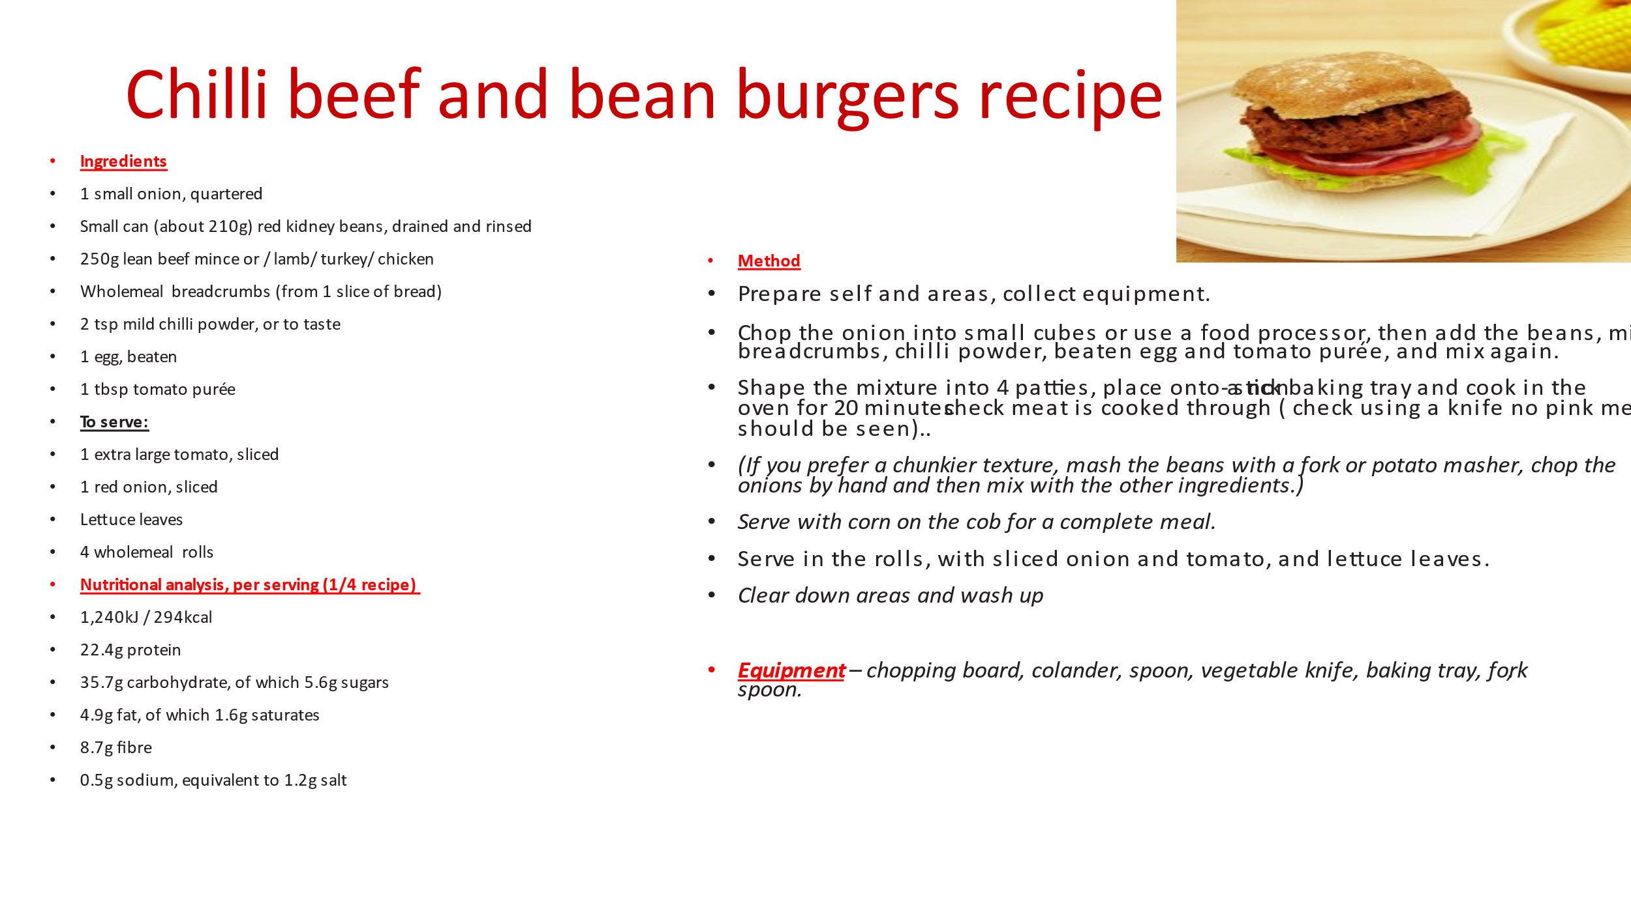

How would you change this recipe if you are a vegetarian, or cooking for someone who is vegetaria